# Student Feedback Portal – Lab Exam Report

BUILD AND RELEASE MANAGEMENT LABORATORY

BYOD-1

# B.Tech. (Computer Science And Engineering)

SUBMITTED TO :

LOVELY PROFESSIONAL UNIVERSITY

PHAGWARA, PUNJAB

SUBMITTED BY :

Name : Lal Harshnath Shahdeo

Registration Number : 12315396

Roll No : 05

**Folder Structure :**

**UNIT TESTS :**

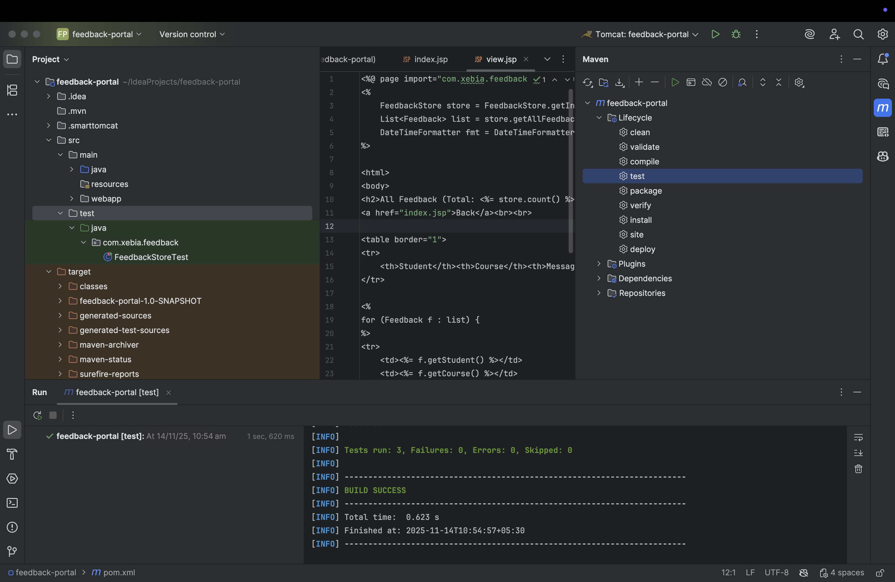

**BUILD FAILS IF ANY TEST FAILS :**

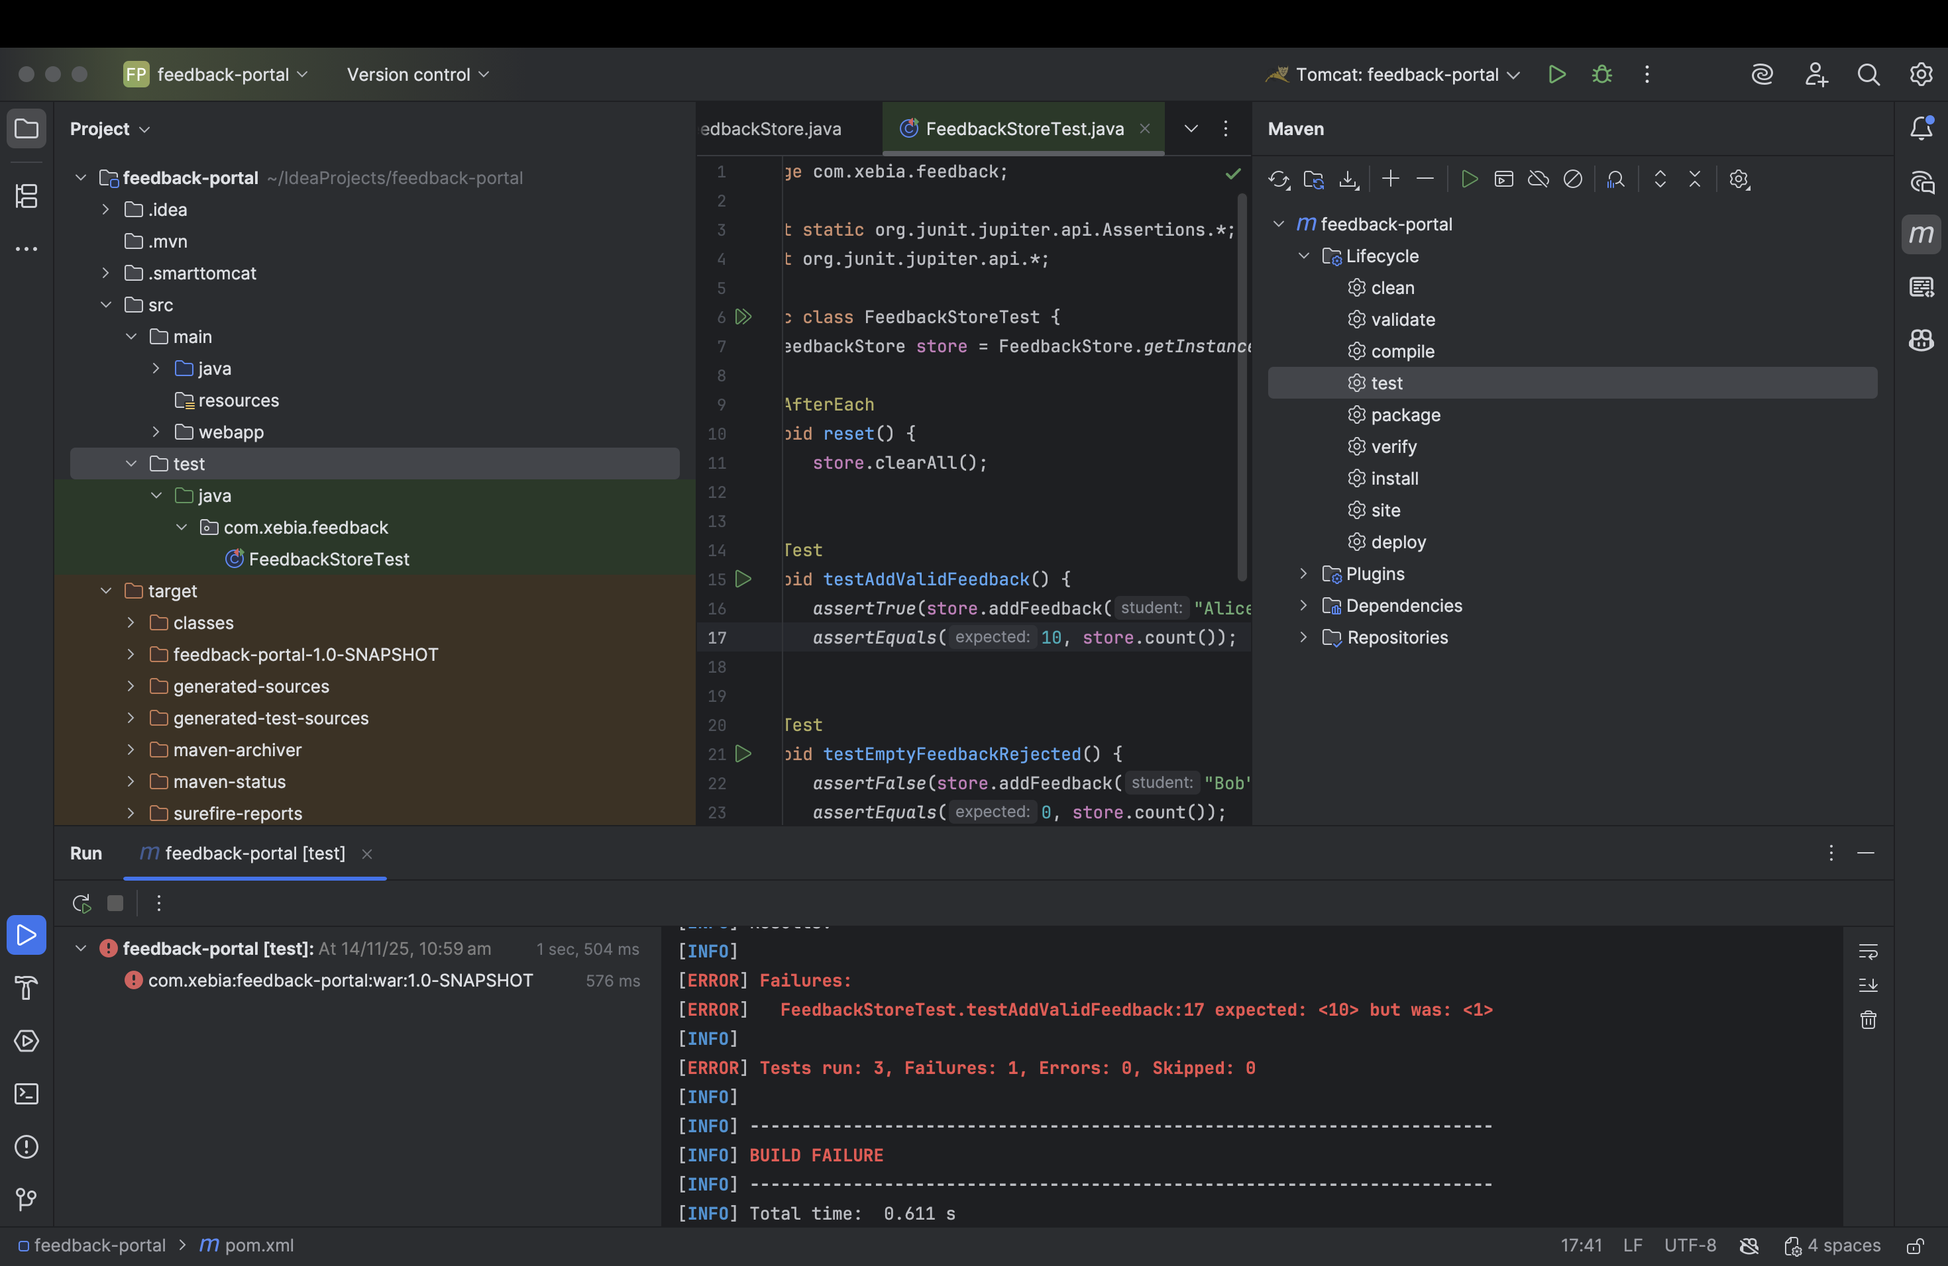

**PACKAGING :**

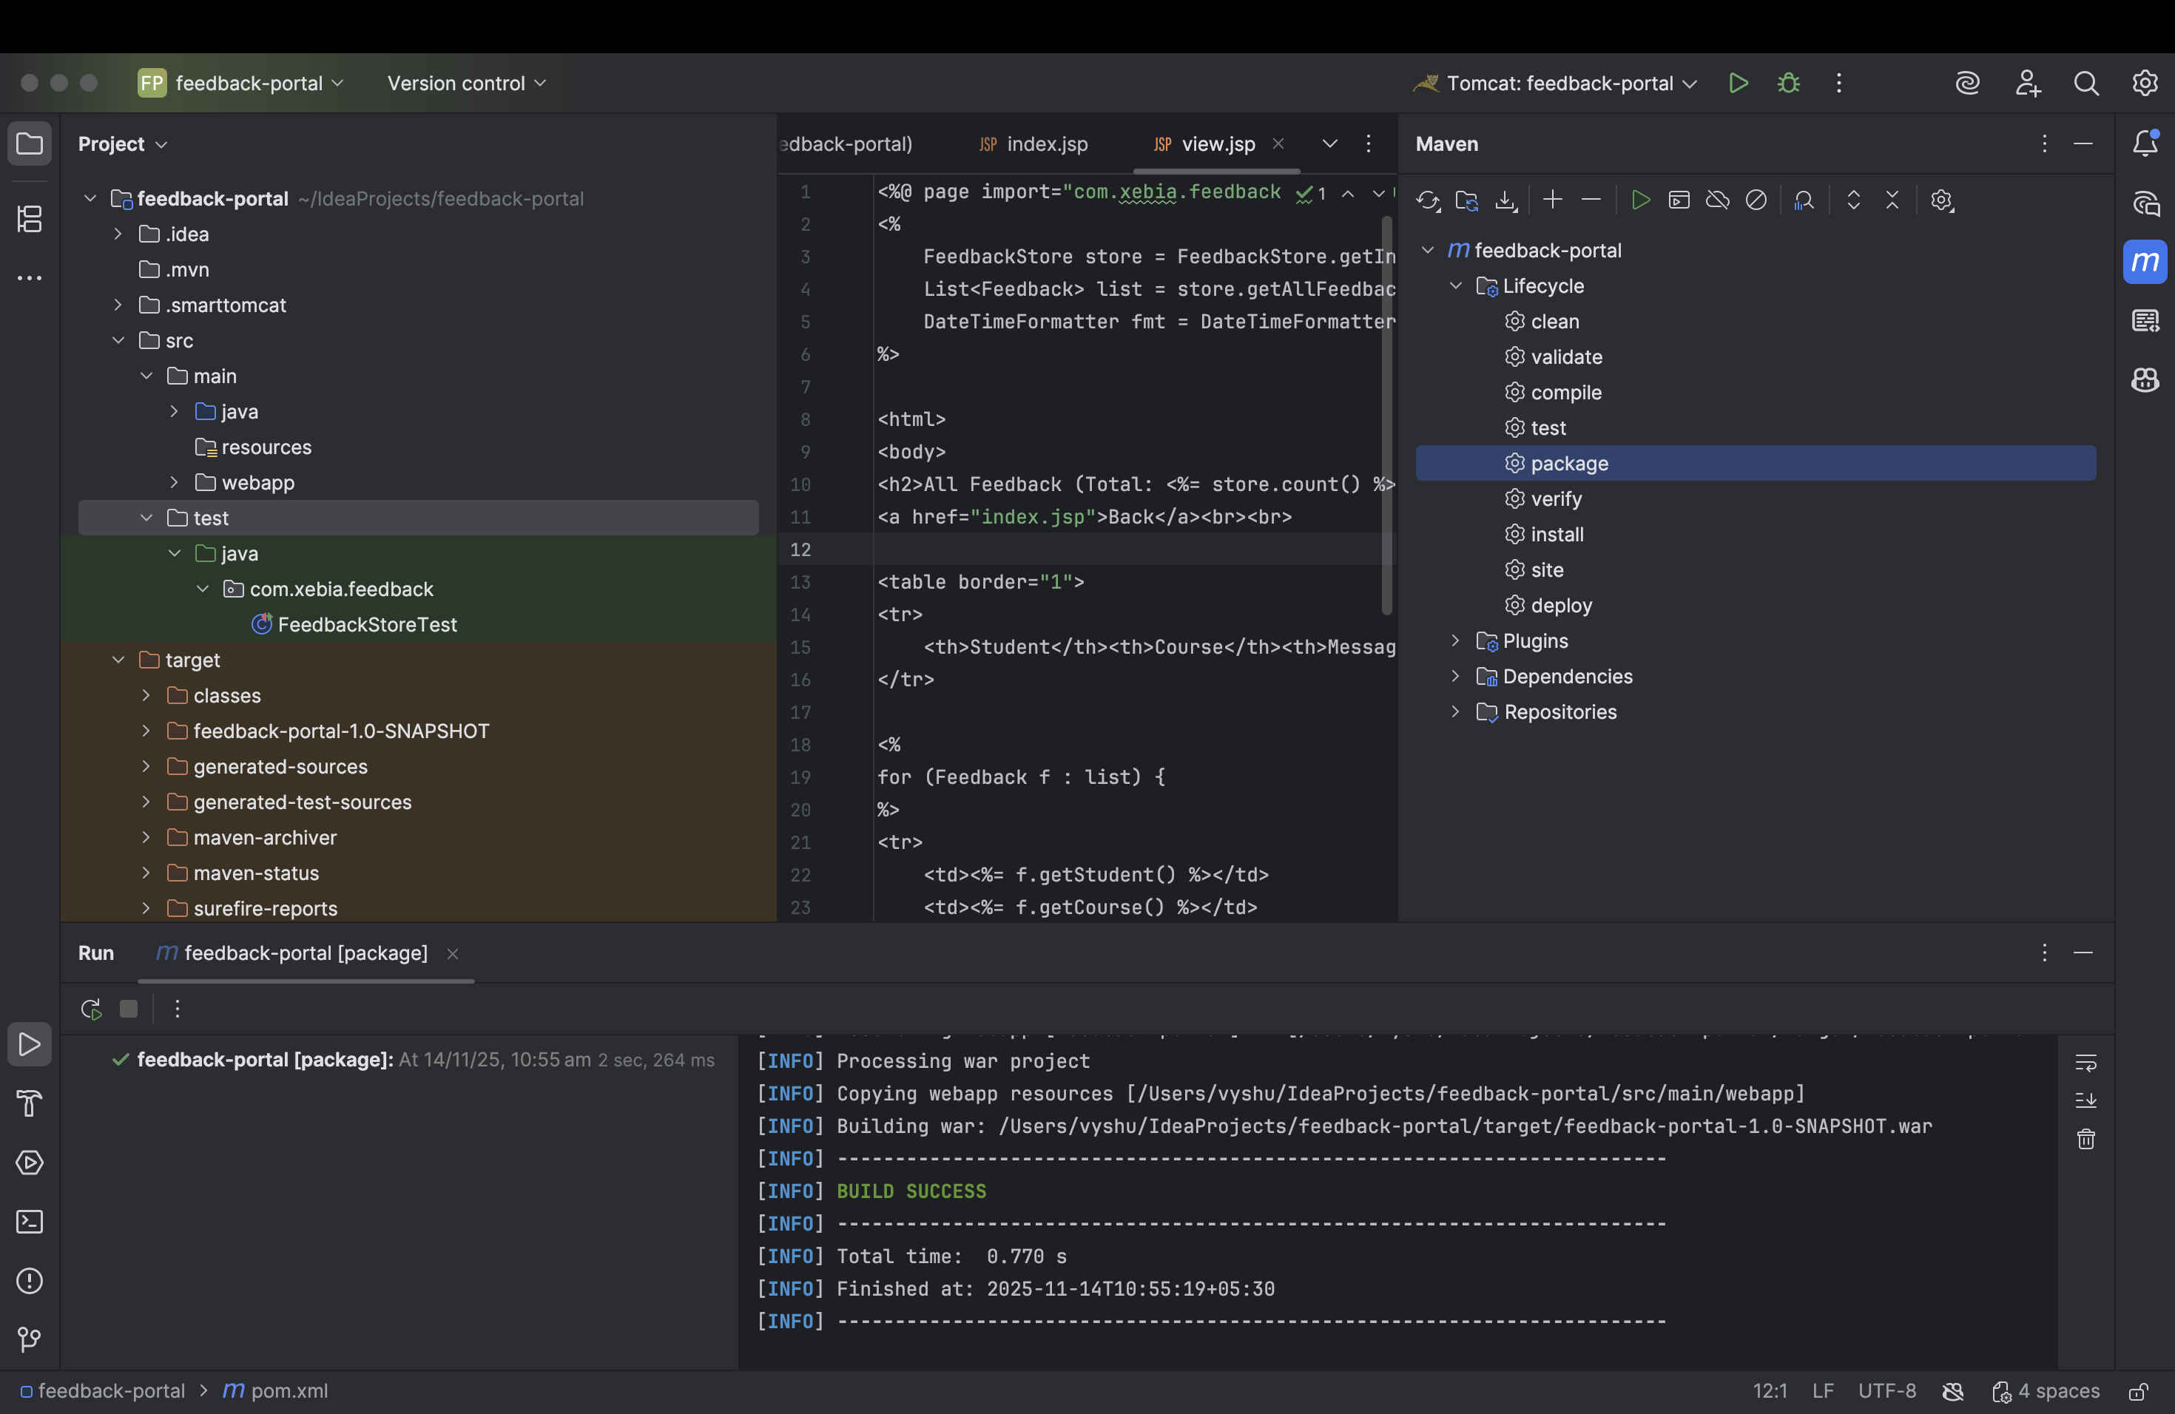

**DEPLOYED THROUGH TOMCAT**

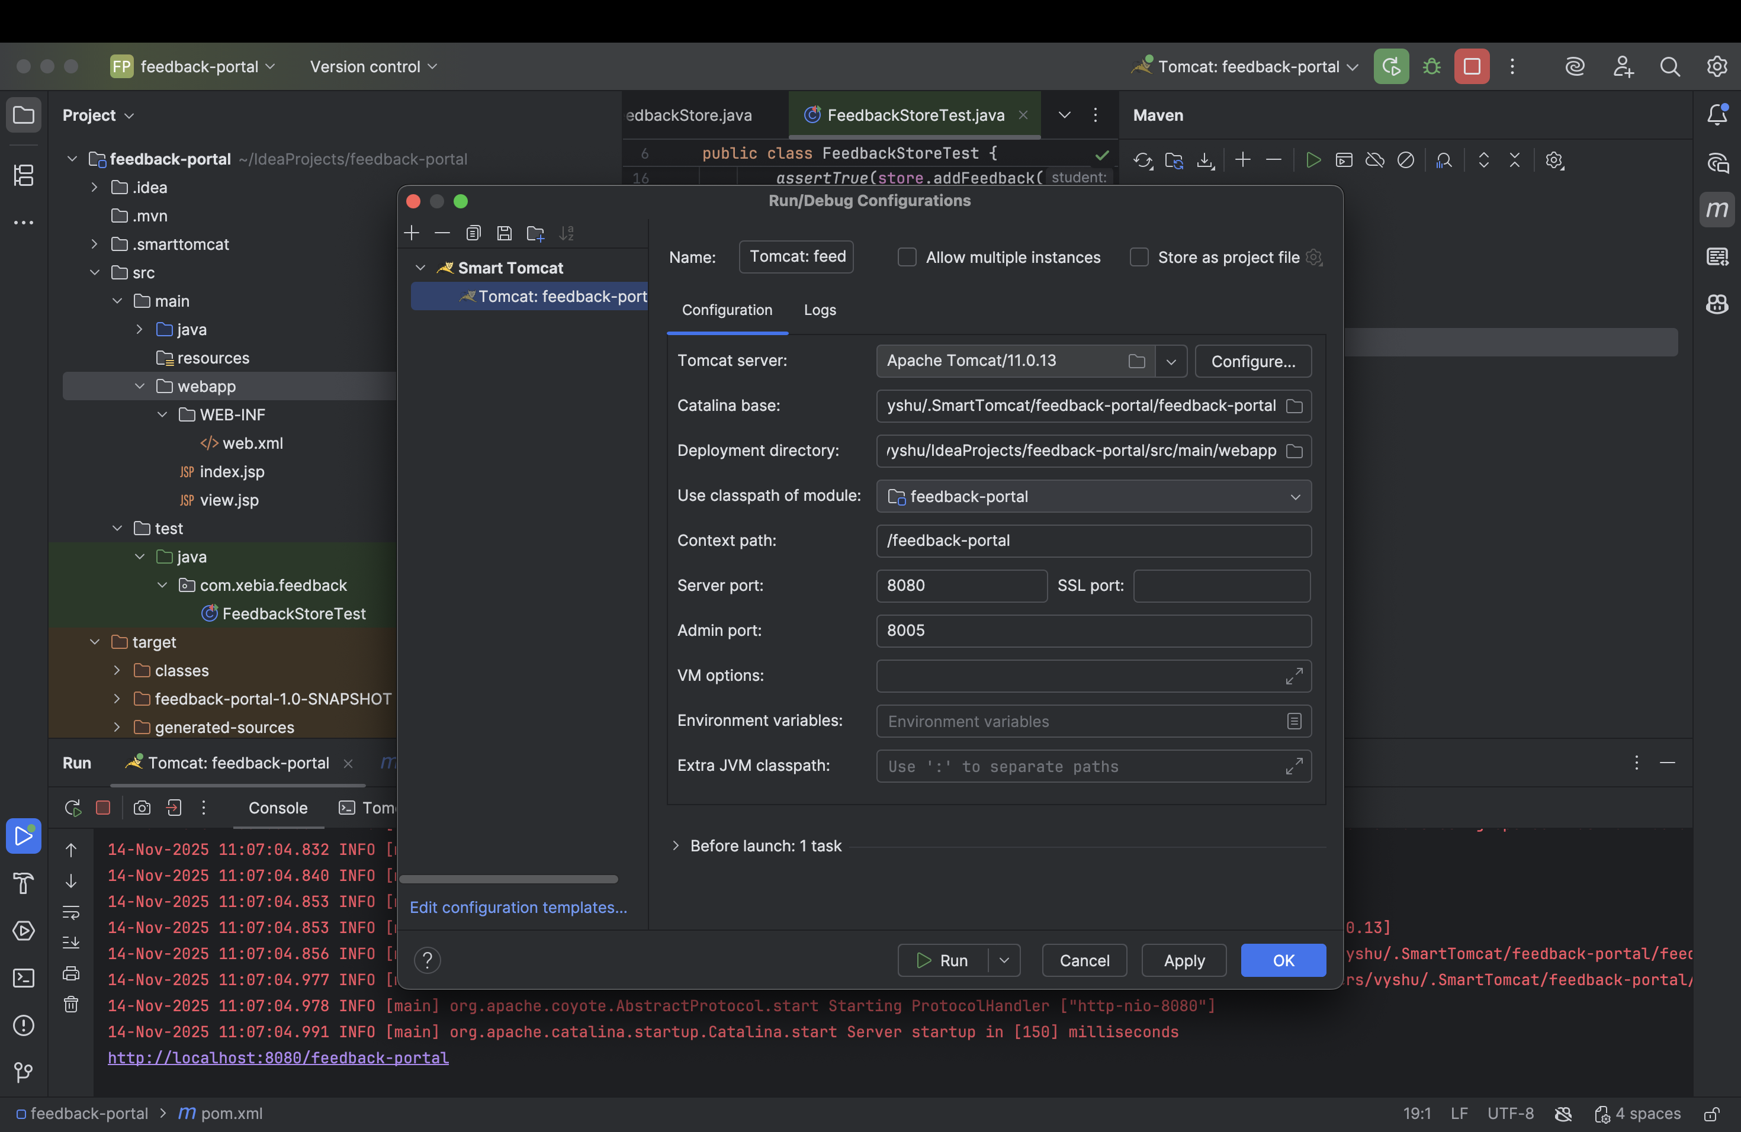

**SUBMIT FEEDBACK PORTAL**

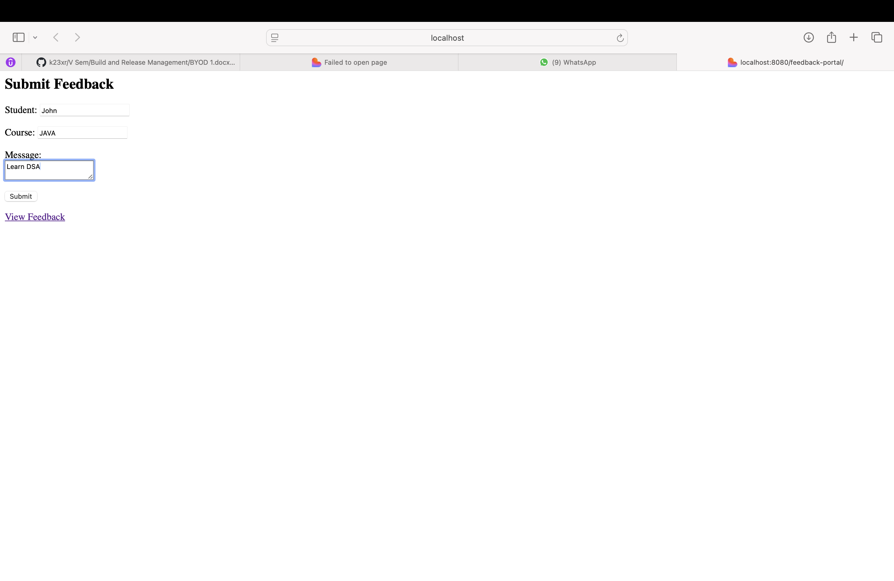

**DISPLAYING THE RESULT :**

**IT DOESN’T ACCEPT EMPTY STRING**

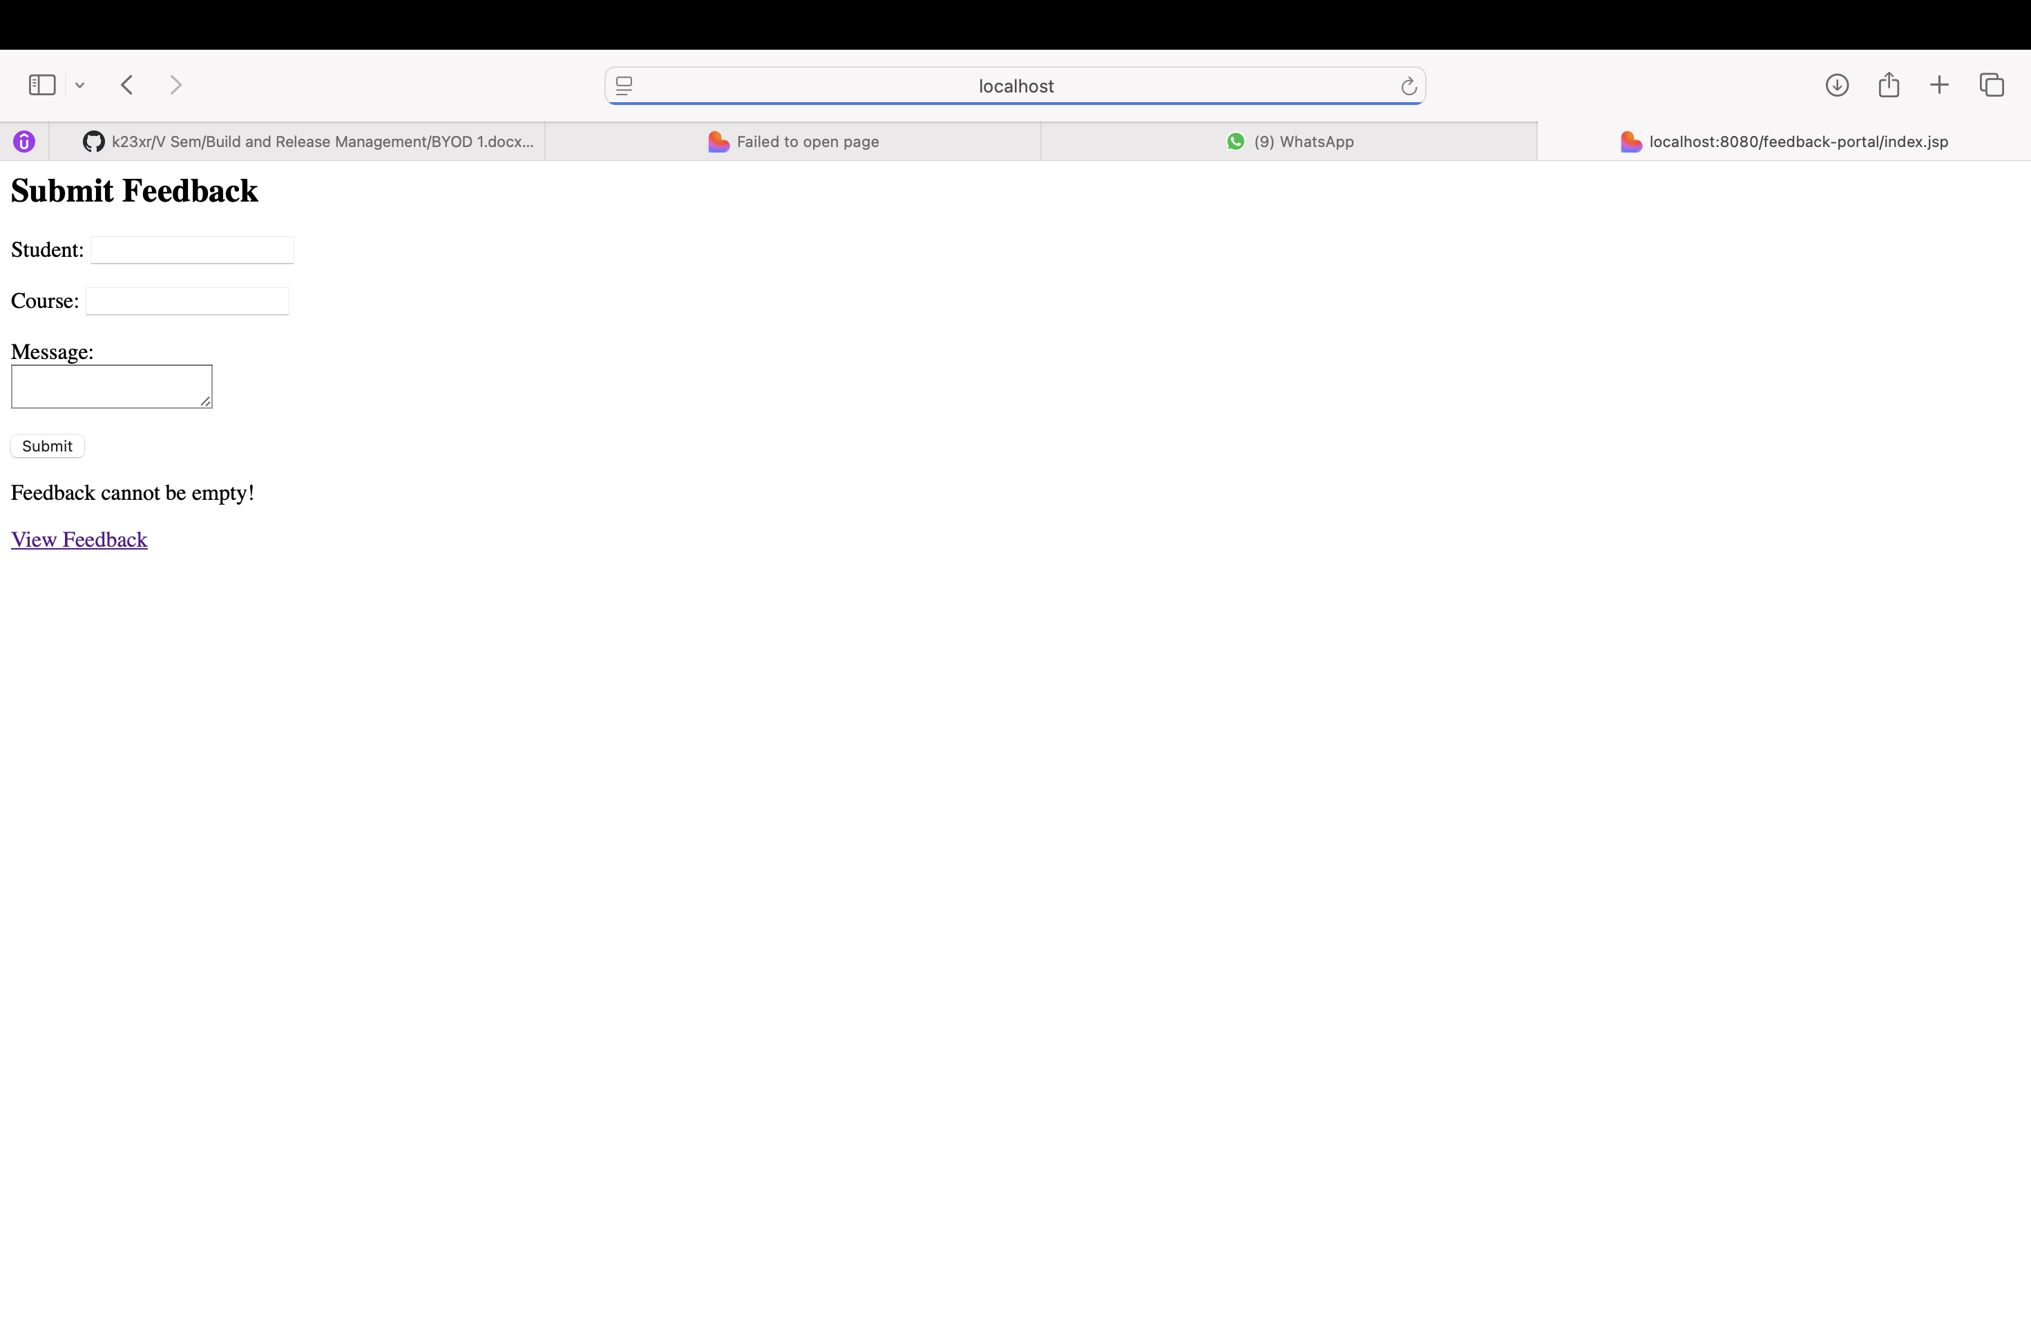

The Student Feedback Portal was developed as a Maven-based JSP web application without using Servlets. The project followed the required architecture and Maven structure. Backend logic for adding, validating, and retrieving feedback entries was implemented in Java using a singleton class (FeedbackStore) to temporarily store data in memory without a database.

JUnit 5 tests were written to verify key functionalities such as feedback addition, rejection of empty entries, and retrieval behavior. Maven Surefire was configured so the build process automatically runs tests and stops packaging if any test fails.

Two JSP pages were created for the user interface:

* **index.jsp** for submitting feedback
* **view.jsp** for displaying all stored feedback

These pages interact directly with the Java backend logic , The project was built using Maven (mvn package) and deployed to Apache Tomcat from IntelliJ. The application ran successfully in the browser, demonstrating feedback submission, retrieval, timestamp display, and total feedback count. All tasks, including optional enhancements, were completed as required.

## 1. Project Structure Screenshot

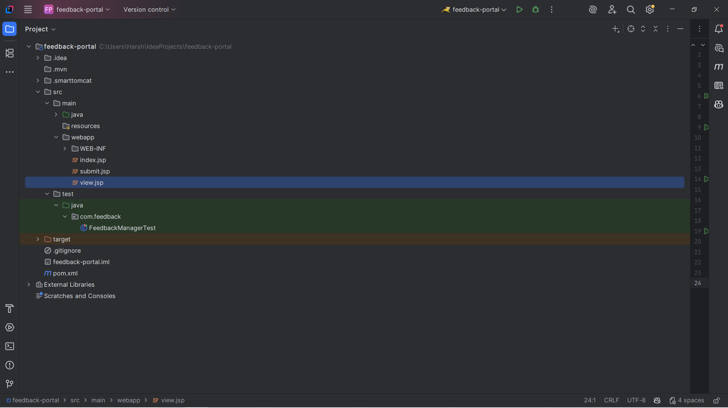

## 2. pom.xml Configuration Screenshot

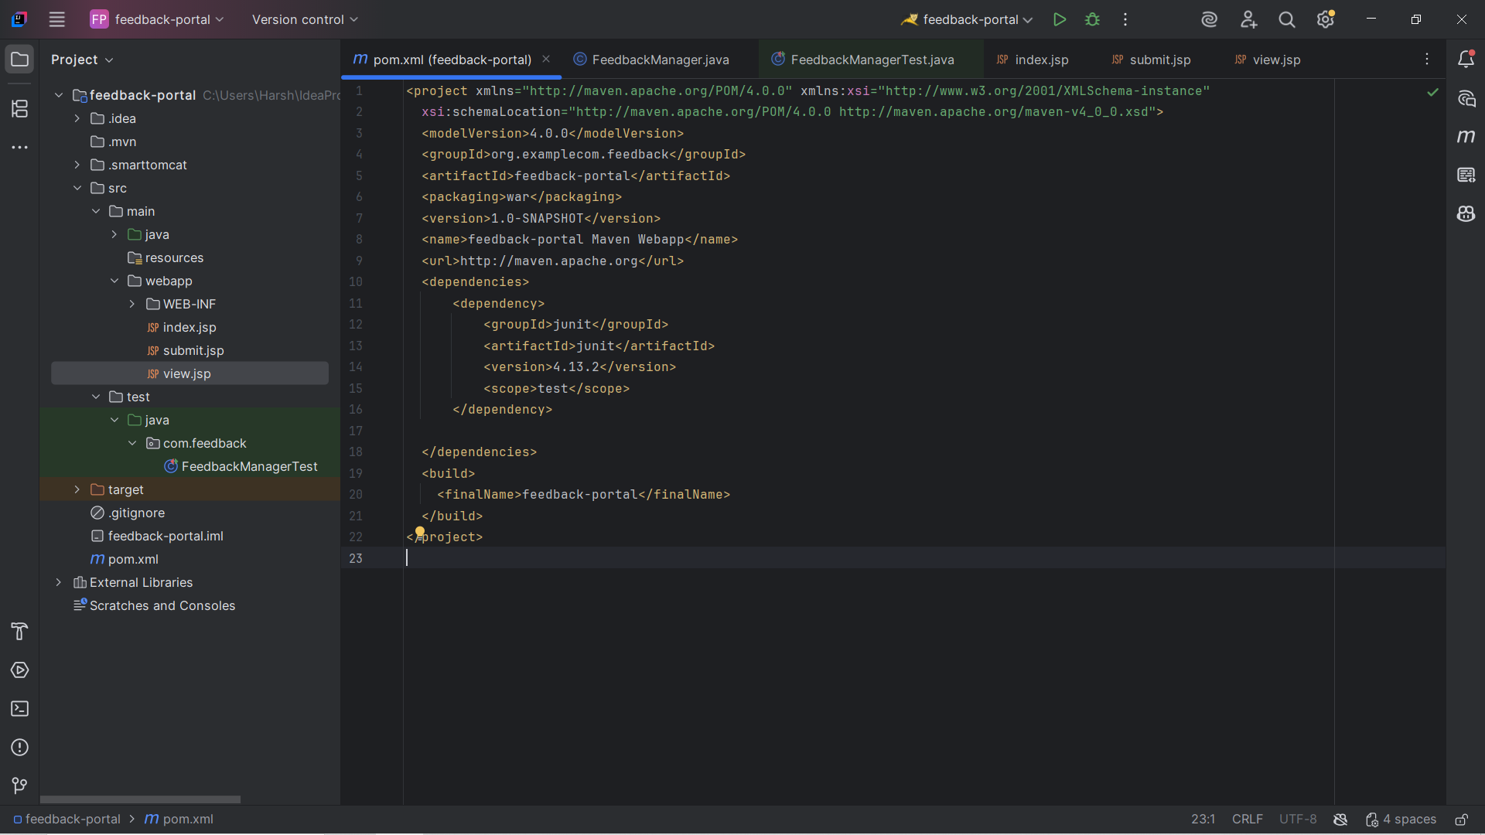

## 3. FeedbackManager.java Screenshot

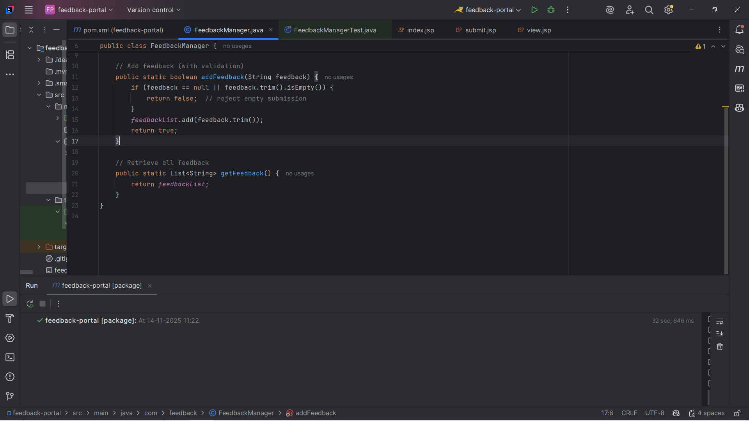

## 4. JUnit Tests Screenshot

## 5. Failed Test Screenshot (Task 6)

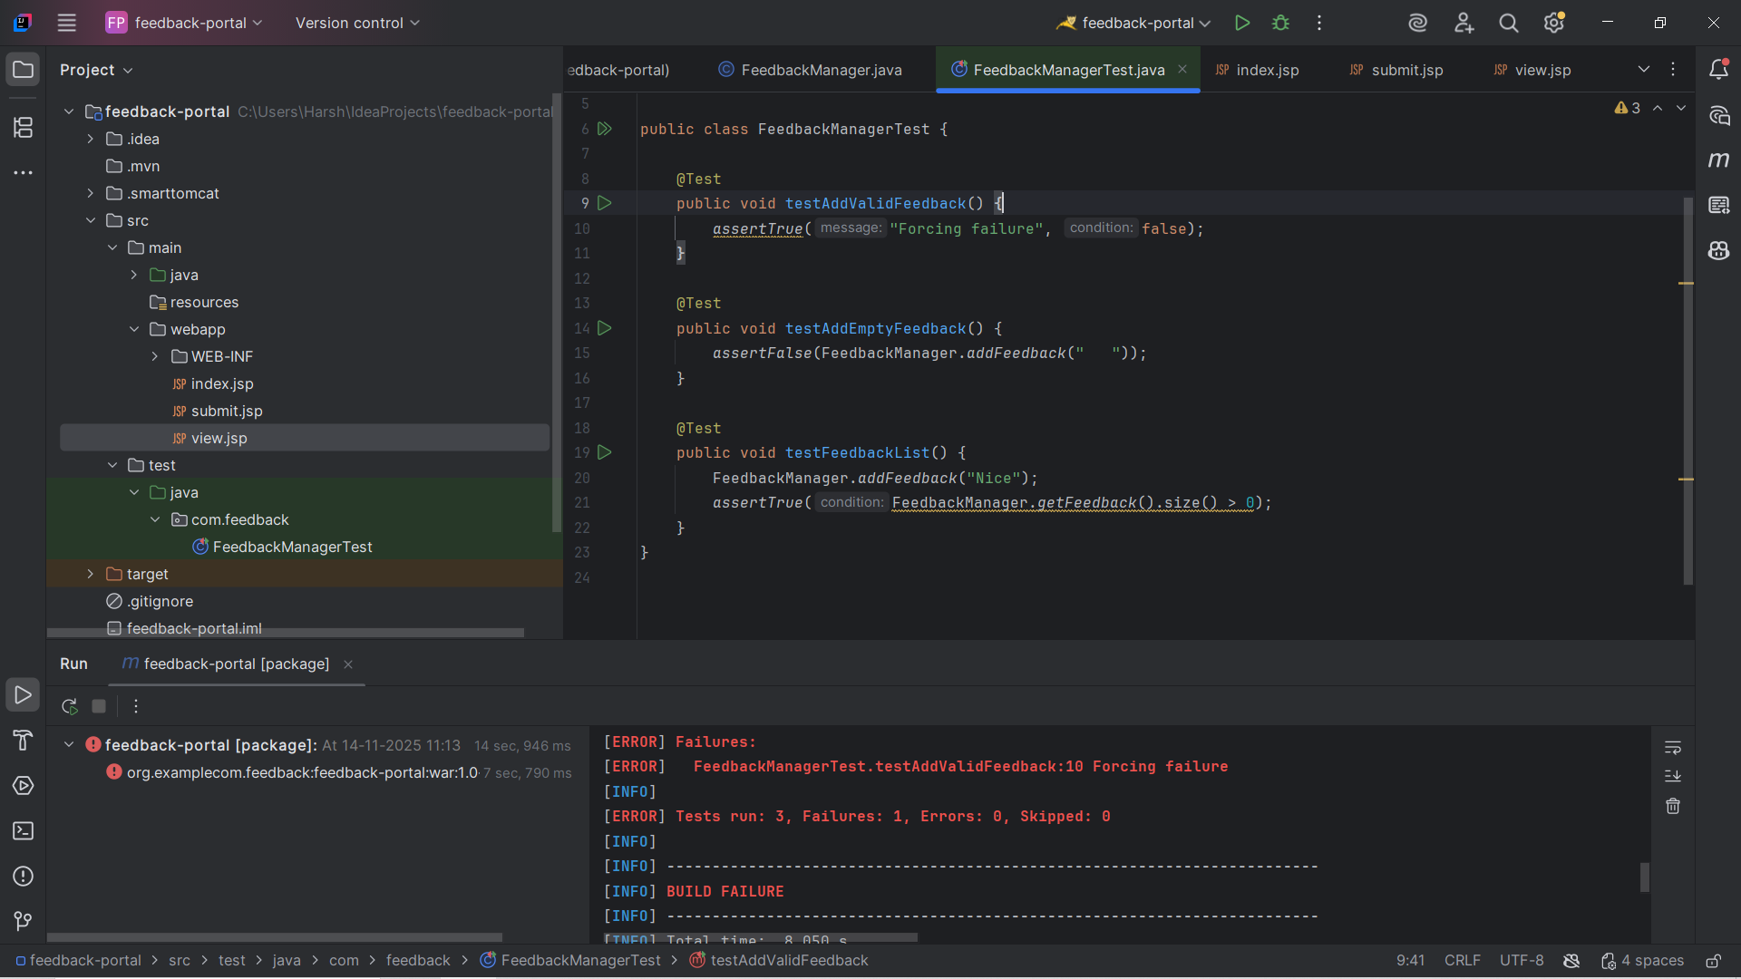

## 6. Successful Build Screenshot

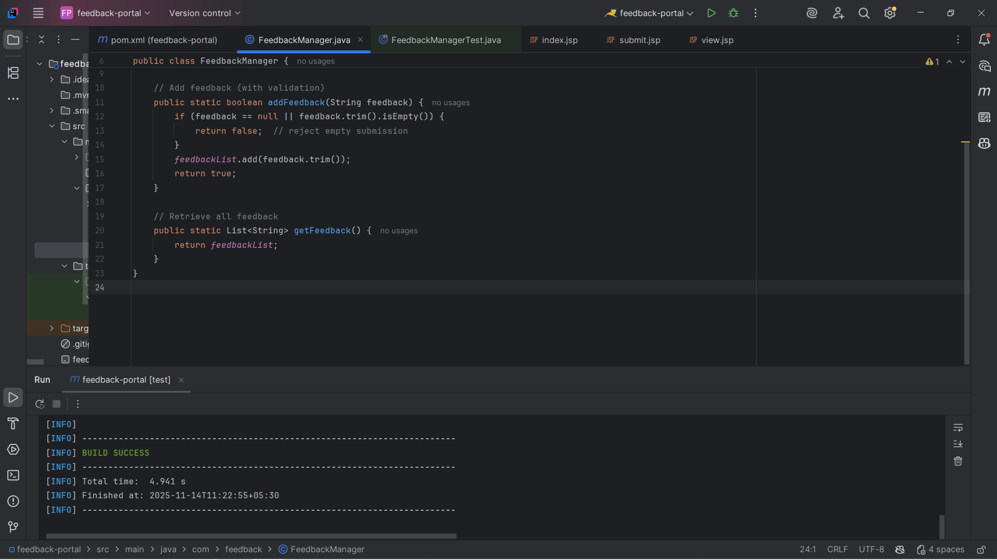

## 7. Tomcat Deployment Screenshot

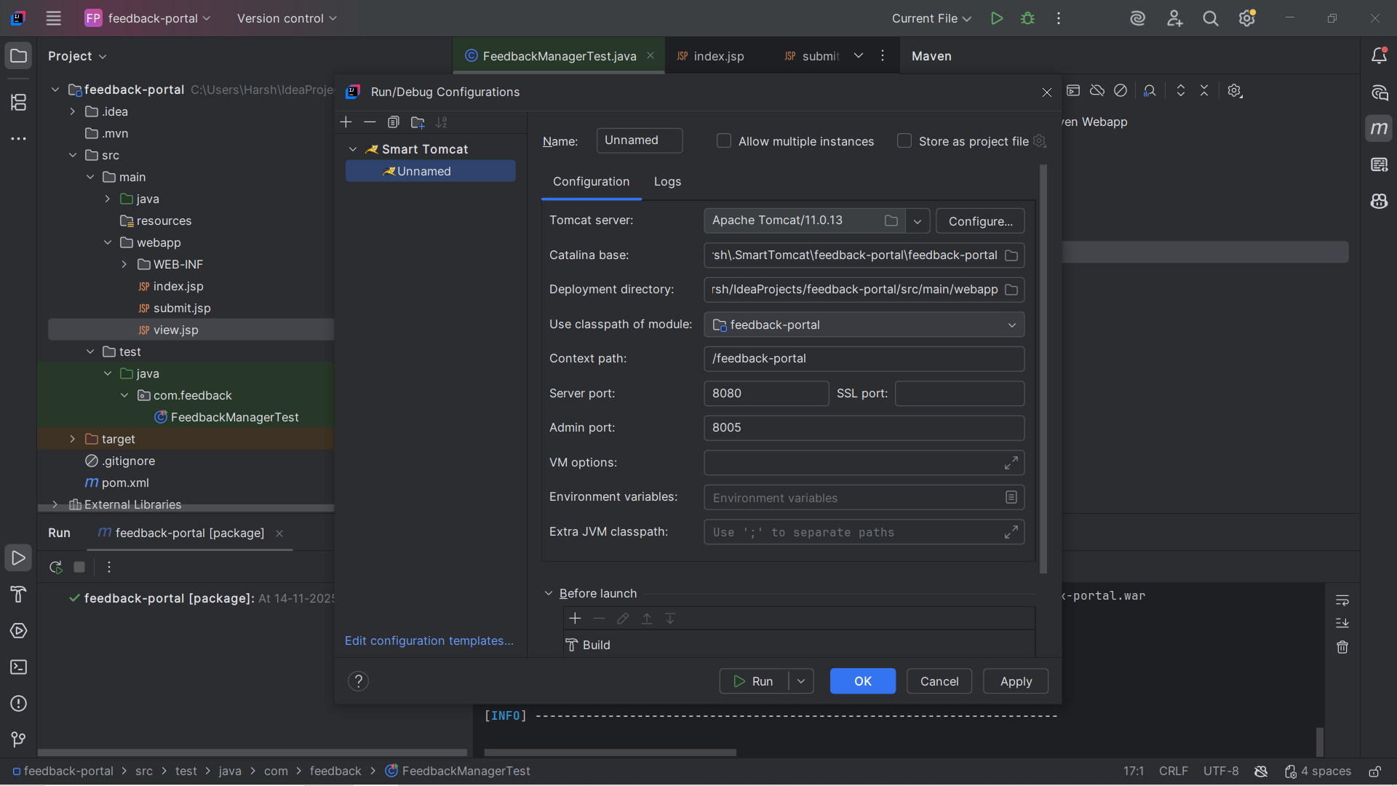

## 8. Application Running Screenshot (index.jsp)

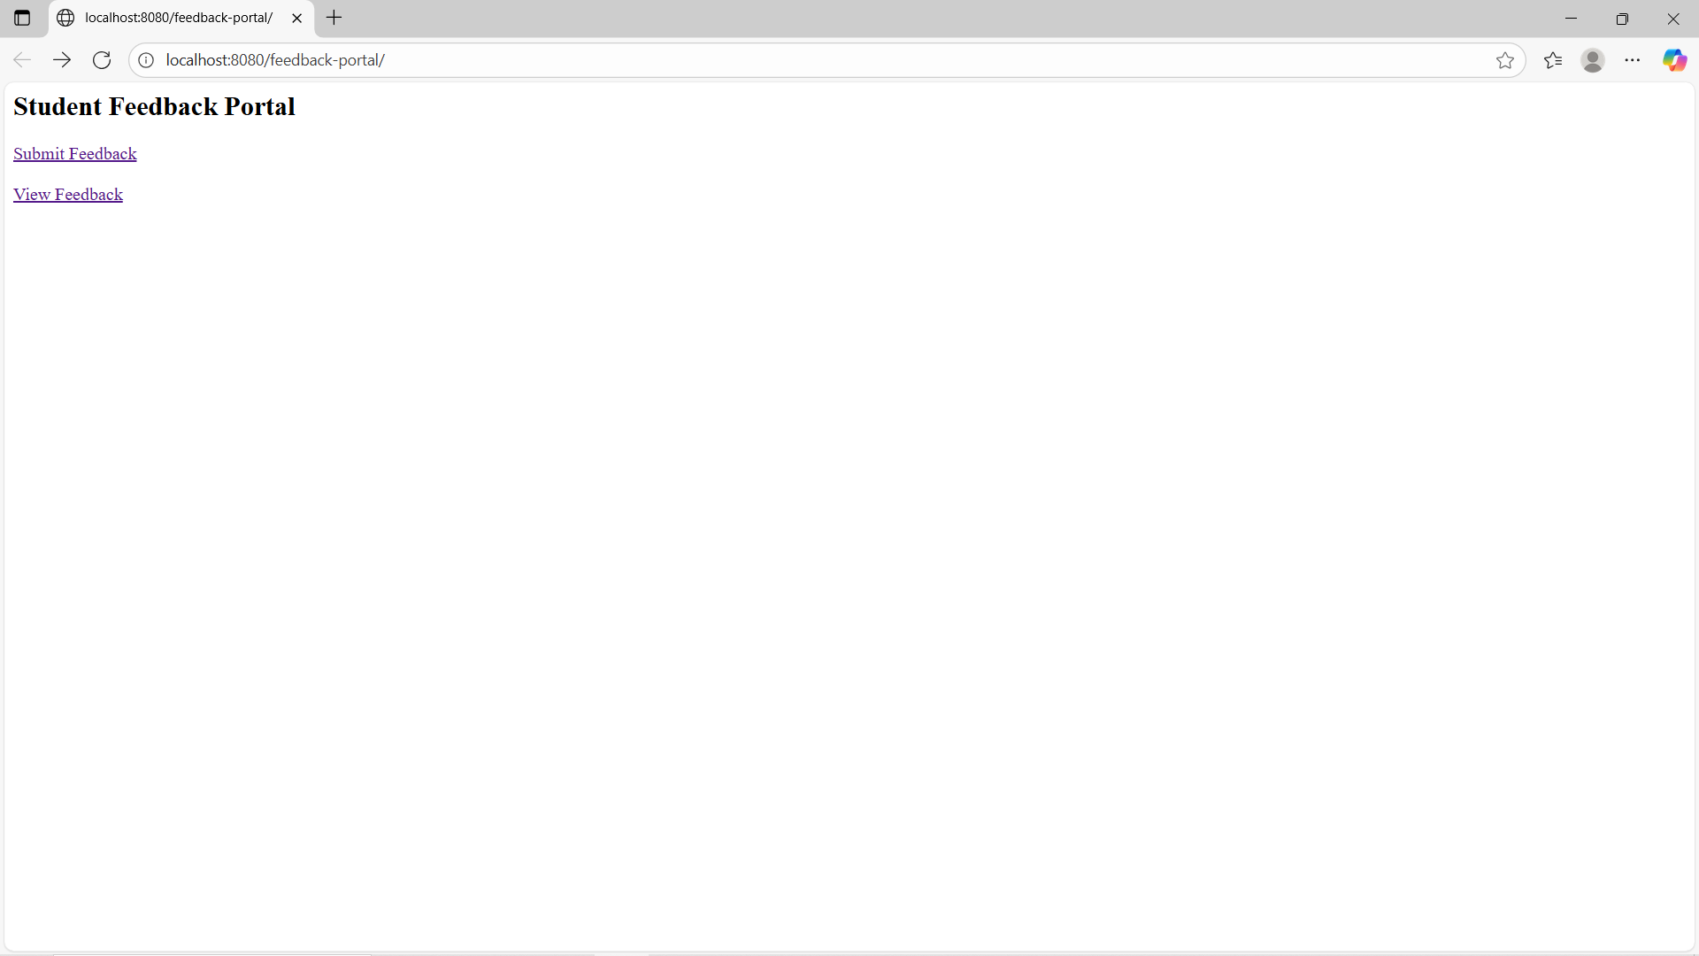

## 9. submit.jsp Working Screenshot

## 10. view.jsp Display Screenshot

## Summary

This report contains all required screenshots and proof of working Student Feedback Portal web application created using Maven, JSP, JUnit, and Apache Tomcat. The project was successfully built, tested, and deployed as per lab requirements.